UCD Graduate Studies
Brightspace Enrolment
Graduate Orientation
graduatestudies@ucd.ie
8-10-2023

Contents
- How to enrol in Orientation for Graduate Research Students 23/24 Explore Module

- How to enrol in Orientation for Graduate Research Students 23/24 Explore Module

- Open Brightspace
- Click on the Explore link in the blue navigation bar
- Search for Orientation for Graduate Research Students 23/24 using the search box

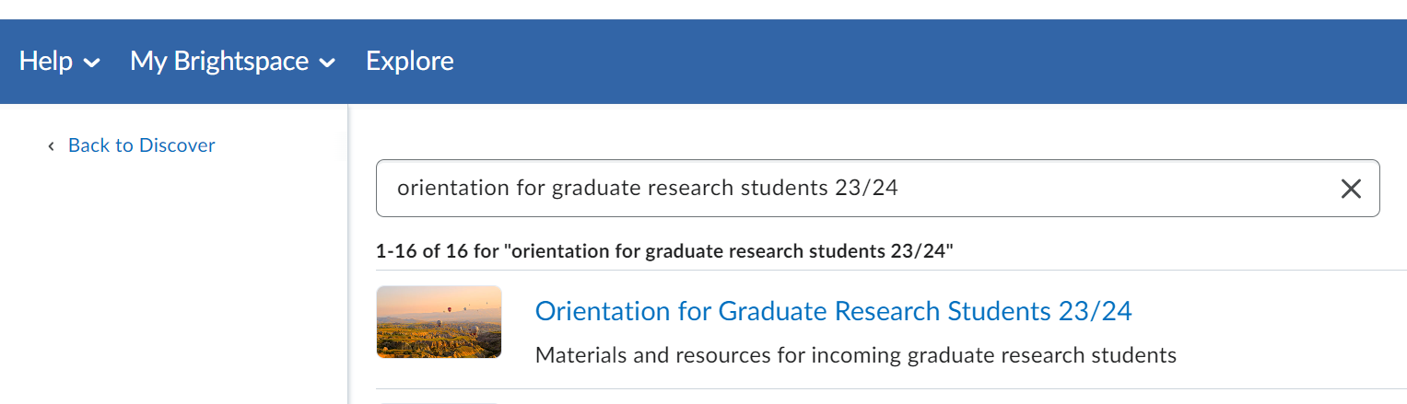

- Click on the module and click the ‘Enroll in Course’ button:

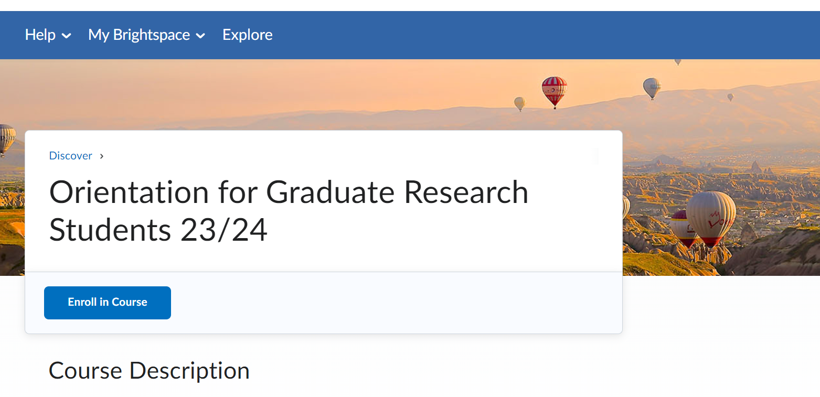

- Once you are enrolled, you can find the module in the My Modules widget on your Brightspace homepage.

